**SNS Project**

Topic has been created inside SNS service also created subscription selecting email and SMS protocols inside the topic created before.

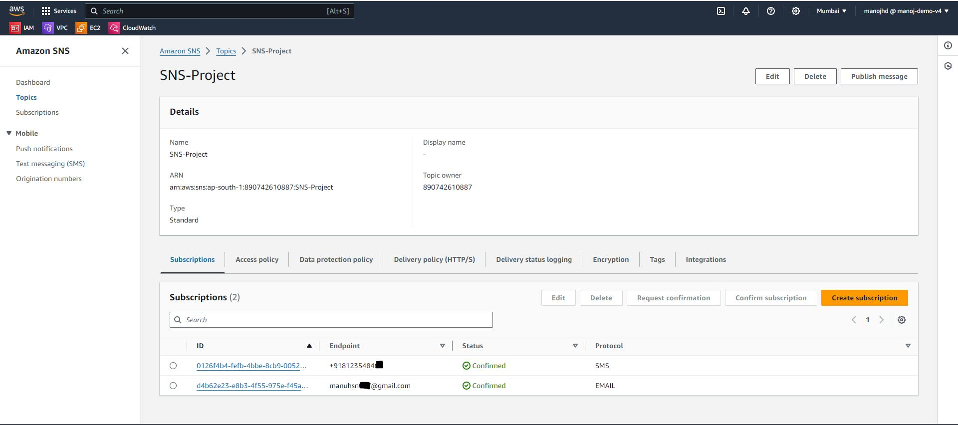

Publish required message to contact or mail ID’s added in subscriptions

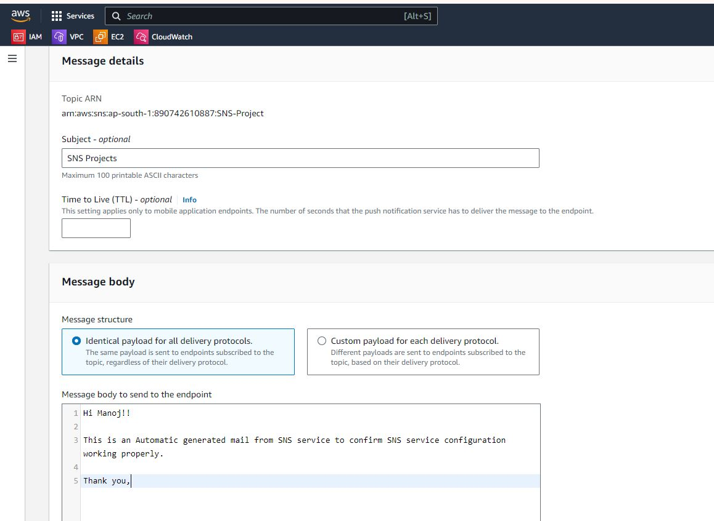

Post publish, message received through both SMS and mail.

